**1. Introduction**

ITP 20002-03 Discrete Mathematics, Fall 2021

**Homework 4**

Kim Hyun Uk

21800201@handong.edu

Hasse Diagram is actually catch the point of undirected graph. Before I print the output of the input data, I have to summarize the traits of indegree. The Input data is formed as “left (space) right” formation. Saving each Name as a number and the array which have the information of indegree and level should be ready. Also, when there is an self to self direction in input file, I have to continue the next line.

Actually, it should be solved using Topological Algorithm, But It needs queue or stack concept. In C language, there are no libraries for using that concept easily. So I approached this with using appropriate array. It’s much easier to use and solve the problem.

**2. Approach**

This code for read the file and save all input data without redundancy. Setting array will save all data of Input file.

This code is for conversion of Input file. The “Input1.dat” file is filled with English but it is too difficult to save and use in another situation. Therefore, I changed each word to number in array name “input”.

This code is for saving the indegree data of each node in array name “level”. Each node has an information of indegree as to Input data file. First, I have to consider the odd index of input array. Because odd number is secondary course of lecture and it is part of indegree counting. And input[i-1] != input[i] means that I have to avoid the situation of self to self direction. In this Input, the Java -> Java.

This code is for Drawing. “matrix” array is saving the number of each level. “max_level” variable saves the maximum number of indegree. “x_data and y_data” array save each coordinate of vertex.

Setting the size of screen.

Set the text and vertex(circle) and Save the coordinates of each vertex to x_data and y_data. To make the graph more beautiful, Width and Height gap should have the rule. I have to count the vertex of each floor. With that, divide the width using that information. Likewise, I have to count the max indegree of Input data file.

This code is for drawing line of graph. Using for loop, when the gap of the level for each input line is 1, draw the line with 2 coordinates.

**3. Evaluation**

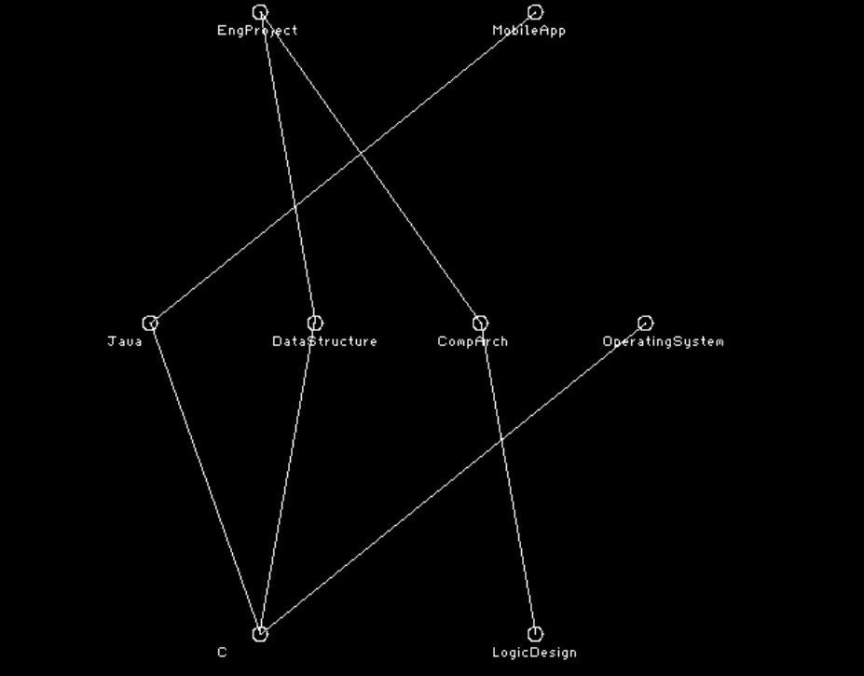

**4. Discussion**

Before I implemented this code, I studied Topological Algorithm. Its main idea is using queue. But C language don’t have the library of this. And the preparation for this was a little bit taking some time to implementation. Therefore I saved all data with Array.

I was wonder how to reduce the number of crossed line. In my case, All data was save as the sequence of Input data file. Therefore I didn’t implement the rotation of that. In my test case, It should be changed Java and Operating System.

**5. Conclusion**

I learned that Hasse Diagram summarize the data more readable. This makes us to comprehend the intension of maker. I totally understand the concept of Graph during solving this problem. Thanks for your teaching.